Task - 3
- Create User (Prateek)
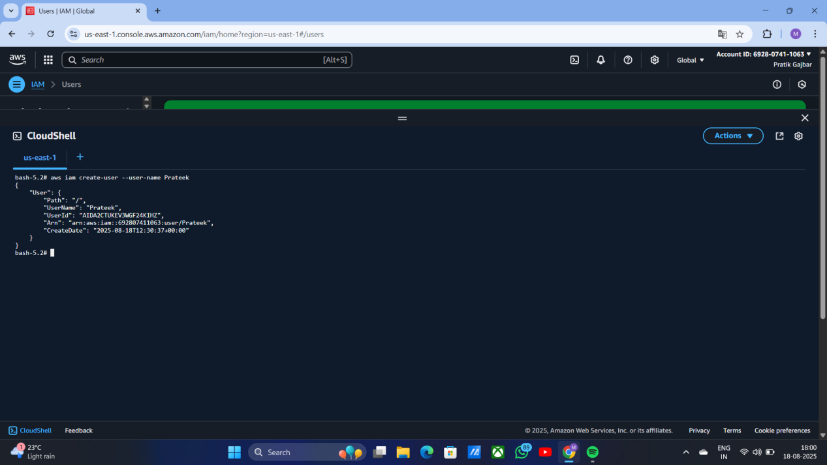

Create Group, Name as (Cloudy)
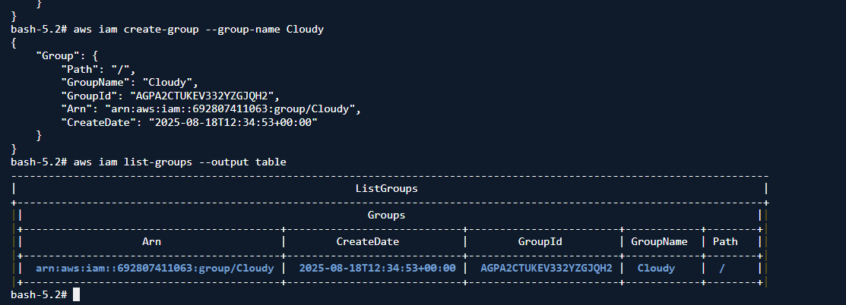

Crate an IAM role using AWS Cloudshell
1 . Create The Trust Policy JSON
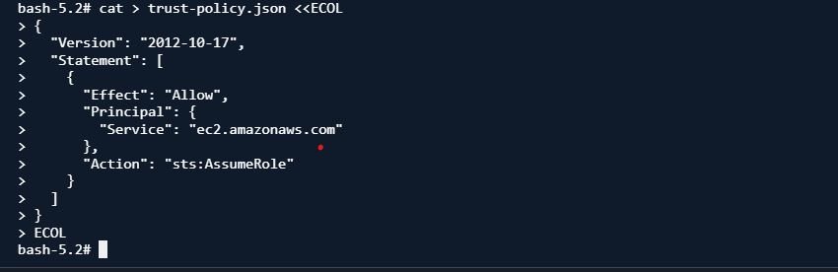

Create Policy and Attach Policy to user (Policy S3 Full access , username - Prateek)

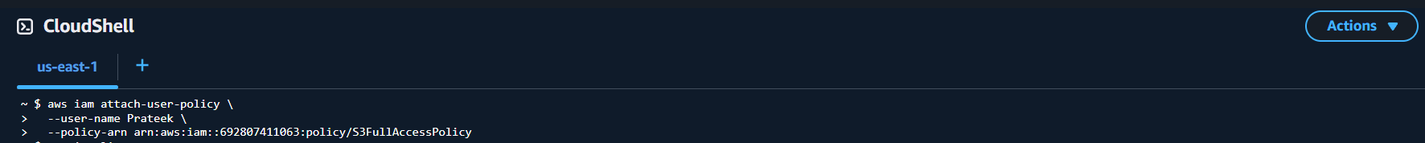
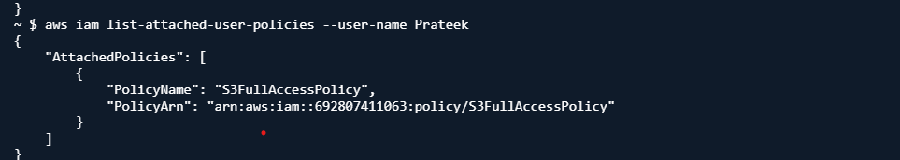

Create the IAM role (Cloudy)

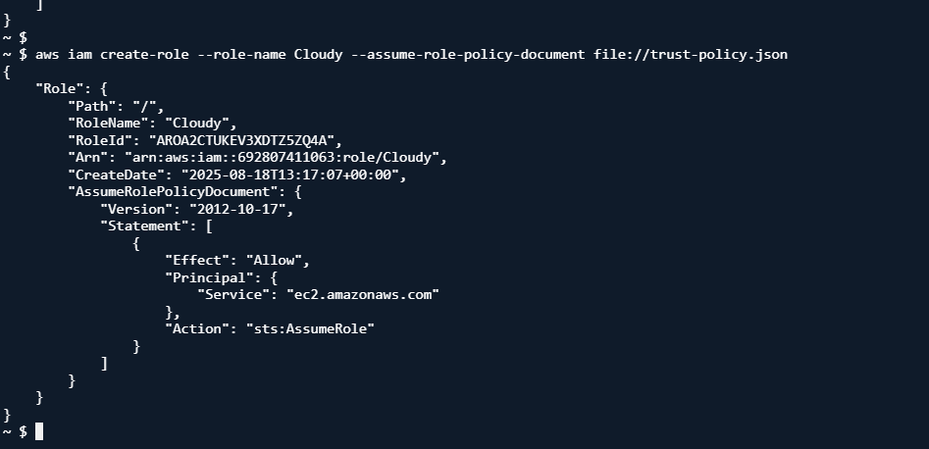

Attach a Policy to the role

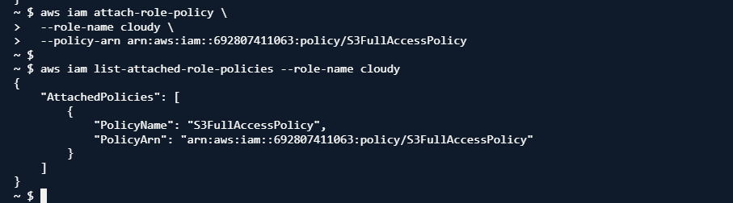

Verify the Role ( output)
